# **PIZZA SALES ANALYSIS USING MSSQL**

The primary objective was to analyse the pizza sales data to extract meaningful insights and key metrics that could guide strategic decisions. This included calculating critical KPIs such as total revenue, average order value, total pizzas sold, and average pizzas per order.

* **Data Aggregation and Calculation:**
  + Computed the **Total Revenue** by summing the total price of all pizza orders.
  + Determined the **Average Order Value** by dividing total revenue by the total number of orders.
  + Calculated the **Total Pizzas Sold** by summing the quantities of all pizzas sold.
  + Counted the **Total Orders** placed.
  + Computed the **Average Pizzas Per Order** by dividing the total number of pizzas sold by the total number of orders.

**SQL QUERIES FOR KPI’S**

1. **Total Revenue:** The sum of total price of all pizza orders.



1. **Average Order Value:** The average amount spent per order calculated by total revenue divided by total number of orders.



1. **Total Pizzas Sold:** Sum of the quantities of all pizzas sold.



1. Total Orders: Total number of orders placed



1. **Average Pizzas Per Order:** Calculated by dividing the total number of pizzas sold by the total number of orders placed.



**SQL QUERIES FOR CHARTS**

1. **Daily Trend for Total Orders: Bar Chart**



1. **Hourly Trend for Total Orders: Line Chart**

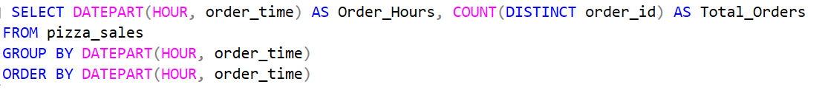

1. **Percentage of Sales by Pizza Category: Pie Chart**



1. **Percentage of Sales by Pizza Size: Funnel Chart**

1. **Total Pizzas Sold by Pizza Category:**



1. **Top 5 Sellers by Total Pizzas Sold: Bar Chart**



1. **Bottom 5 Worst Sellers by Total Pizzas Sold: Bar Chart**



